**Howl: Restaurant Search App**

By Group 4:

Cuong Thinh “Eric” Dao (300275805)

Samuel Navarro (300291991)

Scott Myron (300283742)

# Introduction

Our application is based on the popular restaurant searching application, Yelp [1]. The name of our application, Howl, was chosen because it is a synonym of the verb “yelp”. The initial goal was to produce an application that would use the Yelp API to recommend local restaurants, search for restaurants based on search terms and/or filters, and provide a map view of the locations of these restaurants. Due to issues using the Yelp API with Java it was necessary to change to Foursquare’s API [2] (see Errors section). However, Foursquare is a web application that provides similar services to Yelp. Thus, the main functionality of our application was not hindered by the change. We also created a custom app logo using the free online tool Free Logo Design [3].

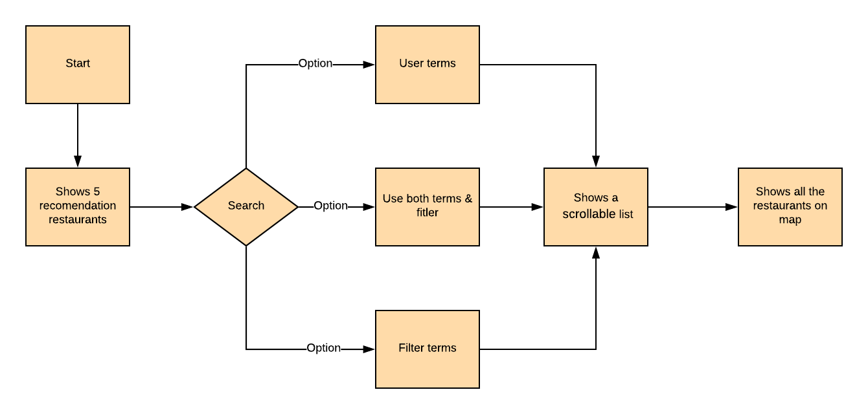

Figure . Flow chart of the Howl application

Figure 1 is a flow diagram of the Howl app. Figure 2 displays the opening screen of the Howl app when the device is geographically located in Douglas College, New Westminster. By default, the app presents a list of five local restaurant recommendations as provided by the Foursquare API. Note that the final version of Howl does not retrieve the geographical location of the device from its GPS but rather must be hardcoded in (see Errors section).

As mentioned, a user can search for restaurants by typing terms in the search text box (Figure 3). The resulting list will provide a scrollable selection of restaurants that fit the search parameters and are located within a 10Km radius of the device. Similarly, a user can search by using preestablished filters as seen in Figure 4. The five available filters are Coffee, Chinese, Japanese, Dessert, and Fast Food. The search feature also works if a user decides to provide both a search term and a filter. For example, a user could decide to set the filter for “Fast Food” but also provide a search term “burger” to find fast food restaurants that specialize in hamburgers.

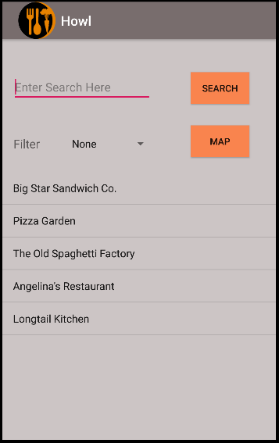It is important to keep in mind that categorization of restaurants in Howl is completely dependent on how Foursquare categorizes specific locals. For example, at Douglas College there is a Tim Horton’s coffee shop in the cafeteria. Although this venue does appear if we provide the search term “Tim Horton’s”, it does not show up if we simply filter for “Coffee”. Meaning that in Foursquare’s database, this Tim Horton’s shop has not been marked with the Coffee Shop ID. Hence the discrepancy with this venue and a couple of others.

Figure . Howl app opening screen with device located at Douglas College

The final feature of the Howl app is the ability to display restaurant search results in a map format. Figure 5 shows an example of such a search. If a user taps on a marker they will see the name of the given local in a small pop-up window above the marker. The user can use the back button on the device to return to the main window. Note that the map markers are only updated when the application is first opened and when the search button is clicked. If the filter is changed and/or a search term is added but the Search button is not clicked, the restaurant markers will be those of the latest search.

# Procedure

Figure . Howl app restaurant search with user provided term "sushi" and device located at Douglas College

When the Howl app starts it runs the MainActivity class. In this class’s onCreate() method we initialize the UI’s View elements (e.g., btnSearch, txtSearch, etc.) and fetch the Client ID and API Key stored in string.xml. More importantly, the recomRestaurants() method is executed. recomRestaurants() is a custom method that executes the API request for the five recommendations of local restaurants. The URL request within the method is defined as follows:

String url = ***BASE_URL*** + inputUrl + **"&ll="** + latitude + **","** + longitude + **"&client_id="** + *clientID* + **"&client_secret="** + *apiKey* + ***API_VERSION***;

Where ***BASE_URL*** is defined as https://api.foursquare.com/v2/venues/ and is common to all Foursquare API requests as defined by their documentation. The inputUrl is provided as an input to the 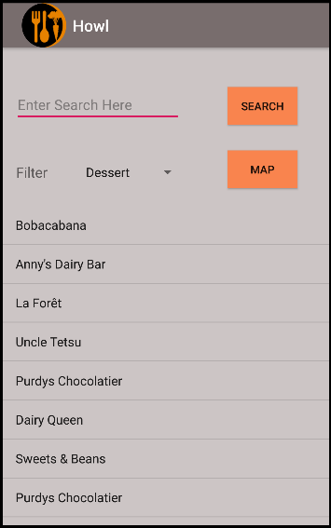method and is defined to be the string explore?section=food&limit=5, which are the parameters that will limit the API response to 5 venues of type food. Note that we need to specify section=food with Foursquare. Their web application is a service to find interesting places to visit in an area, not just restaurants. The **ll** URL parameter is the longitude and latitude of the device, which are provided as inputs to the recomRestaurants(). The **client_id** and **client_secret** parameters are the Client ID and API Key respectively, which are global variables. Finally, ***API_VERSION***

Figure . Howl app restaurant search with filter term "Dessert" and device located at Douglas College

is defined as the string &v=20181115 where the URL parameter v is the API’s version and is writen in a YYYYMMDD date format. This last parameter is also common amongst all Foursquare API requests.

recomRestaurants()consists of 49 lines of code, but the most relevant portion is the following 10 lines within the definition of onResponse():

Figure . Howl app restaurant search in Google Map display with device located at Douglas College

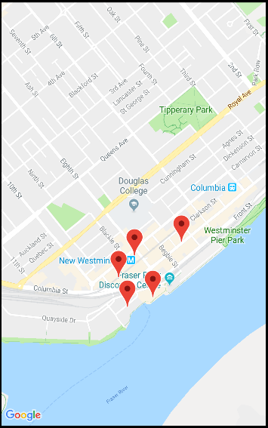**for**(**int** i = 0; i < restaurants.length(); i++){  
 JSONObject restaurant = restaurants.getJSONObject(i).getJSONObject(**"venue"**);  
 JSONObject location = restaurant.getJSONObject(**"location"**);  
  
 **name** = restaurant.getString(**"name"**);  
 **lat** = location.getDouble(**"lat"**);  
 **lng** = location.getDouble(**"lng"**);  
 **result**.add(**new** Restaurant(**name**, **new** LatLng(**lat**, **lng**)));  
}

Prior to the for-loop we have already filtered the JSON response to the point where two JSON objects can be declared, restaurant and location. From these objects, we can obtain the restaurant names, latitudes, and longitudes which will be used as parameters to instantiate Restaurant objects. These objects are iteratively added into a **result** list of type List<Restaurant>. Restaurant is a custom class created to hold relevant information to each local. This would be the class where attributes could be added to also hold information such as a venue’s rating or address. These could then be displayed in Howl’s search results. However, due to issues with adding sub-elements to a ListView, this was not implemented (see Errors section). Note that rendering the restaurant list into the ListView of the MainActivity is performed by updateListView(). We will describe this method later in this section.

After a user has opened Howl, they can start searching for venues by filters or search terms. We will first describe how a filter is created. Filters are relevant to explaining how searching by terms works. The following is the click-listener for the Search button:

**btnSearch**.setOnClickListener(**new** View.OnClickListener() {  
 **@Override  
 public void** onClick(View v) {  
  
 String filter = setFilter();  
  
 *//Search for restaurants by the given search terms and filters within 10Km.* String url = **"search?"** + filter +

**"&radius=10000&query="** + **txtSearch**.getText().toString();  
 searchRestaurants(**latitude**, **longitude**, url);  
  
 }  
});

A user selects a filter via the Spinner in the main window. When a user taps the Search button, the variable filter is set by setFilter(). This method is a simple switch that will look at the selection made in the Spinner and output the corresponding categoryId parameter value. Note that there is always a default categoryId for “Food” since the Foursquare API will search for none food related venues otherwise. Once setFilter() has provided a categoryId we execute searchRestaurants(), which uses the filter as part of its input. The URL request for a Foursquare venue search is very similar to that of a venue recommendation. The only differences are the addition of the radius, and query parameters. These fields set the radius of the search and the query terms respectively. In addition, we replace section with categoryId for similar results. The definition of searchRestaurants()is nearly identical to that of recomRestaurants()with a for-loop adding restaurants to a list.

As mentioned before, rendering the restaurants into our ListView is performed by updateListView(). This method is called by both recomRestaurants()and searchRestaurants()with the corresponding restaurant list as parameter. The main body of updateListView()consists of:

*itemsList* = **new** ArrayList<>();  
*locations* = **new** ArrayList<>();  
  
**for** (Restaurant restaurant:  
 restaurants) {  
 **if** ((restaurant.get_name() != **null**) && (restaurant.get_latlng() != **null**))  
 {  
 *itemsList*.add(restaurant.get_name());  
 *locations*.add(restaurant.get_latlng());  
 }  
}  
  
ArrayAdapter<String> adapter = **new** ArrayAdapter<>(**this**,  
 android.R.layout.***simple_list_item_1***, *itemsList*);  
**lstResults**.setAdapter(adapter);

The purpose of this method is twofold. The main task is to use the adapter to update our ListView with the names of the venues in the input list, restaurants. The second task is to also add the restaurants locations to the static global list *locations*. This list will be called in the MapActivity to render the markers for the venue locations.

When the Map button is tapped, the user is redirected to the MapActivity. When MapActivity is ran it initially checks if Howl has permission to use the device’s location in Google Maps. If the app does not yet have permission, the user is prompted to provide it via a dialog. If permission has already been granted the application continues. The onLocationChanged() method is overridden within the onMapReady() method. This method was repurposed to iterate through the static list *locations* and *itemsList* from the MainActivity. Using the stored locations, markers representing the restaurants are added to the Google Map. At the same time, the names in *itemsList* are used as tags for the markers.

# Results

The final Howl application was very much as planned. Once the app is opened, five recommendations of local restaurants is provided. Our search by filter/search term work as expected. as does the map feature. Aside from some esthetical improvements, this was a successful project.

Given more time, there are some aspects that could be improved. Our current restaurant list only displays the name of the restaurants. If there are many venues with the same name these will not be distinguishable in our app expect for on the map. We attempted to add either pictures of the venues or their addresses as subitems in the ListView. However, with limited knowledge on how to update this class during runtime, this was not completed before delivery of the project. An alternative would have been to retrieve the address and concatenate it into the name of the restaurant. This would have worked as then both name and address would have been a single string and no subitem would have been required. However, many names and addresses are long. This would result in very lengthy text as list items, which did not look esthetically correct. For this reason, the solution was rejected. Another aspect that needs upgrading is the use of hardcoded latitude and longitude values. Using the GPS location of the device would make Howl much more robust and useful in a real-world setting.

# Errors

The first problem we faced was not an actual error but a lack of support. It appears that the Yelp API was recently upgraded from version 2 to version 3, or Yelp Fusion. As of today, it seems that there is no official support for Java in this API version [4] except for some 3rd party libraries [5]. This is the reason another API provider was required.

The first code related error we had was with retrieving the device’s GPS location. We initially had a version of “working code” that would indeed retrieve the GPS location from the device. Unfortunately, this code only worked because we implemented MapActivity and ran it in the emulator before adding the location code to the app. MapActivity uses Google Maps, which has integrated methods that request permission to retrieve the device’s location. Since the emulator already granted permission to use the device location, our code worked seamlessly. That is, up until we ran our code in a clean emulator. With no permission, we could not retrieve the location of the device or subsequently make API requests. Attempting to integrate the permission requests at the start of the app did not seem to fix the problem. Thus, we were forced to revert to hardcoded latitude and longitude.

Finally, we attempted to stylize the ListView items to add pictures and address text into Howl’s list of restaurants. After extensive research, many different solutions were found but only one that seemed to satisfy our requirements. The process consisted in structuring each list element to our desired specifications using an xml file [6]. Then, a custom class would integrate this structure to each ListView item. The concept appeared sound, but the code did not seem to work when modified to accommodate our desired structure.

# References

1. <https://www.yelp.ca/vancouver>
2. <https://developer.foursquare.com/docs>
3. <https://www.freelogodesign.org/>
4. <https://github.com/Yelp/yelp-fusion>
5. <https://github.com/ranga543/yelp-fusion-android>
6. <https://www.learn2crack.com/2013/10/android-custom-listview-images-text-example.html>